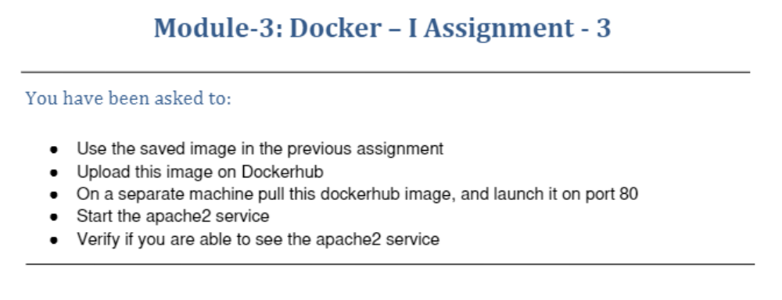
ubuntu@ip-172-31-39-74:~$ sudo docker login
Login with your Docker ID to push and pull images from Docker Hub. If you don't have a Docker ID, head over to https://hub.docker.com to create one.
Username: veerannagatate
Password:
WARNING! Your password will be stored unencrypted in /root/.docker/config.json.
Configure a credential helper to remove this warning. See
https://docs.docker.com/engine/reference/commandline/login/#credentials-store

Login Succeeded
ubuntu@ip-172-31-39-74:~$ sudo docker images
REPOSITORY TAG IMAGE ID CREATED SIZE
veerannagatate/apachenew latest 3a61383fa440 12 hours ago 217MB
ubuntu latest 597ce1600cf4 13 days ago 72.8MB
ubuntu@ip-172-31-39-74:~$ sudo docker push veerannagatate/apachenew
Using default tag: latest
The push refers to repository [docker.io/veerannagatate/apachenew]
e5e45ff32b28: Pushed
da55b45d310b: Mounted from library/ubuntu
latest: digest: sha256:db44436ec6b1ad89633f696b0b909f1cf48840dc0703b4d239e23ee1dd9ece89 size: 741
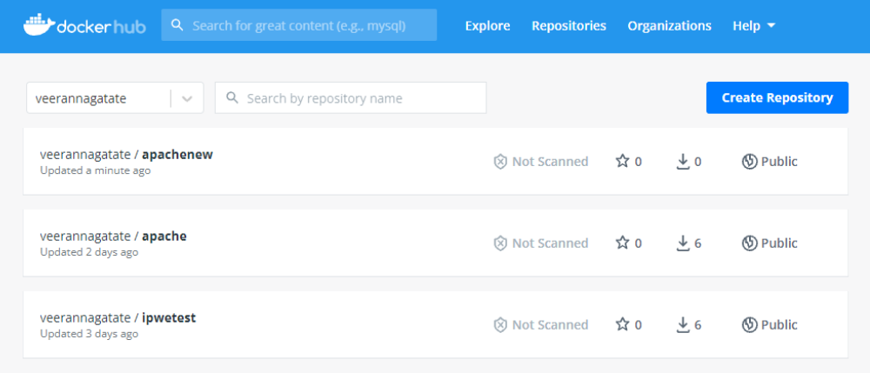
ubuntu@ip-172-31-39-74:~$ sudo docker login
Authenticating with existing credentials...
WARNING! Your password will be stored unencrypted in /root/.docker/config.json.
Configure a credential helper to remove this warning. See
https://docs.docker.com/engine/reference/commandline/login/#credentials-store

Login Succeeded
ubuntu@ip-172-31-39-74:~$ sudo docker images
REPOSITORY TAG IMAGE ID CREATED SIZE
veerannagatate/apachenew latest 3a61383fa440 12 hours ago 217MB
ubuntu latest 597ce1600cf4 13 days ago 72.8MB
ubuntu@ip-172-31-39-74:~$ sudo docker run -it veerannagatate/apachenew
root@1dd77d72b9c1:/# service apache2 status
* apache2 is not running
root@1dd77d72b9c1:/# service apache2 start
* Starting Apache httpd web server apache2 AH00558: apache2: Could not reliably determine the server's fully qualified domain name, using 172.17.0.2. Set the 'ServerName' directive globally to suppress this message
*
root@1dd77d72b9c1:/# service apache2 status
* apache2 is running
root@1dd77d72b9c1:/# exit
exit
ubuntu@ip-172-31-39-74:~$ sudo docker commit 1dd77d72b9c1 veerannagatate/apache2
sha256:3aaaa5e1607b5c11064a624ab2db3109c216e14f1b52fe5d564adc450c993fbf
ubuntu@ip-172-31-39-74:~$ sudo docker images
REPOSITORY TAG IMAGE ID CREATED SIZE
veerannagatate/apache2 latest 3aaaa5e1607b 12 seconds ago 217MB
veerannagatate/apachenew latest 3a61383fa440 12 hours ago 217MB
ubuntu latest 597ce1600cf4 13 days ago 72.8MB
ubuntu@ip-172-31-39-74:~$ sudo docker run -it -p 82:80 veerannagatate/apache2
root@5091aba66023:/# exit
exit
ubuntu@ip-172-31-39-74:~$ sudo docker run -it -p 82:80 -d veerannagatate/apache2
e2beb2a16fa80a6665ae0e7804ae7a1c43254473f48bc5e0d3b0feb29fc99158
ubuntu@ip-172-31-39-74:~$ sudo docker ps
CONTAINER ID IMAGE COMMAND CREATED STATUS PORTS NAMES
e2beb2a16fa8 veerannagatate/apache2 "bash" 15 seconds ago Up 14 seconds 0.0.0.0:82->80/tcp, :::82->80/tcp sad_cori
ubuntu@ip-172-31-39-74:~$ sudo docker exec -it e2beb2a16fa8 bash
root@e2beb2a16fa8:/# service apache2 status
* apache2 is not running
root@e2beb2a16fa8:/# service apache2 start
* Starting Apache httpd web server apache2 AH00558: apache2: Could not reliably determine the server's fully qualified domain name, using 172.17.0.2. Set the 'ServerName' directive globally to suppress this message
*
root@e2beb2a16fa8:/# service apache2 status
* apache2 is running
root@e2beb2a16fa8:/# exit
exit
